**Work-Practices Contract**

Cari Himel (cjh326), Joaquin Amante (aya24), Ryan Kim (rk494)

We agree to the following policies for our team. Once agreed to, these policies cannot be  
changed for the duration of the project.

1. Team roles. Any specific roles within the group, their responsibilities, and how those roles will be assigned or rotated.

**All three group members are equal contributors to the assignment. Since there are three submissions for the project, each team member will be responsible for organizing a submission prior to the due date. We will determine further specific roles as we learn more about each of our best skill sets (with front end, etc.).**

1. Decision making. For example: consensus, majority vote, or team captain

**We will make decisions using a majority vote system. Since there are three people in the group, there will always be a majority.**

1. Communication. Methods of communication, and expectations for response times.

**We will have a GroupMe where we consistently communicate, and determine times to meet up in person. It will be expected that we all respond in a timely fashion to any form of communication. We can also email in cases of emergency. Communication with our TA will predominantly be via email as well, unless face-to-face meetings are required.**

1. Meeting times. When and where you will meet, expectations for attendance.

**We will meet in Duffield and all are expected to attend when we have meeting times. We will put them accordingly to when we are all free. Each week we will find an afternoon when we are all free and meet then, typically Thursday or Friday after 4pm.**

1. Balance of responsibilities. Procedures for ensuring that everyone contributes.

**Through active communication and team deadlines we will ensure that each member is responsible for their individual deliverables. We will have frequent meetings so that everyone can report on the status of their work and bring to light any issues they may be facing. Our GroupMe will also be used as a means of communicating problems, issues, or other important news between group members.**

1. Conflict Resolution. What we will do when we identify problems, and how we will resolve  
   Them.

**First round of problem solving is communication. Since we will consistently be in contact with one another we can give instantaneous feedback regarding each member’s progress and work. In cases where negotiation is impossible, we will use a majority vote much like with decision-making.**

1. Availability. When each member will not be available for any reason and how you will work around these absences.

**As of right now, our schedules are pretty aligned with when we are free. We are all away for Spring Break, however.**

Signatures:

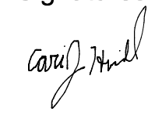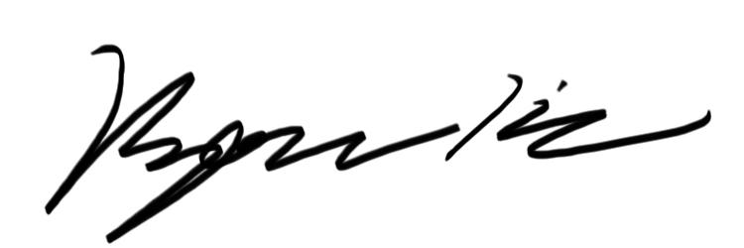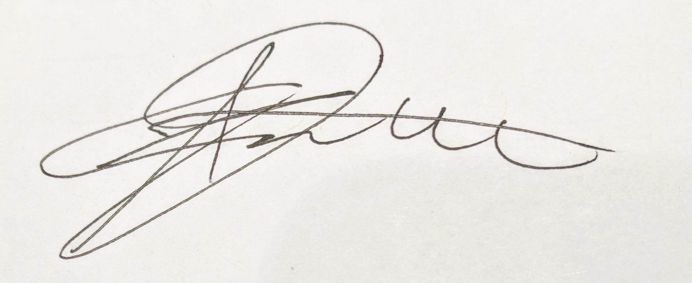

TA Witness Signature:

